Umar Mustapha
umustapha874@gmail.com
Global Olympics Medal Overview
Country performance, gender distribution, and sport dominance analysis

Introduction
The dataset captures global Olympic medal data, tracking country name, medal type (Gold, Silver, Bronze), medal value, athlete name, gender, sport, and games year. Together these variables provide a full view of how medal success is distributed across nations, genders, individual athletes, and sports.
Competition Composition
The dataset spans multiple countries, with the United States of America and the People's Republic of China as the two clear medal leaders, alongside Japan, ROC, Great Britain, and the Netherlands rounding out the top six. It also tracks five sports directly (Athletics, Swimming, Wrestling, Judo, and Boxing) and highlights individual athlete performance across a broader set of disciplines, including Short Track Speed Skating, Cross Country Skiing, Artistic Gymnastics, and Taekwondo.
Story of the Data
This dataset tells the story of how Olympic success concentrates, in a handful of dominant nations, in specific sports, and in a small group of standout athletes. It shows that medal success is rarely spread evenly, certain countries dominate certain sports entirely, certain athletes accumulate disproportionate individual value, and certain disciplines (Athletics especially) generate far more total medal volume than others.
Industry Type
The dataset belongs to the Sports Analytics domain, with a specific focus on international competition performance and athlete achievement tracking.
It is relevant to the following areas:
- International Sports Performance Analysis
- National Olympic Committee Strategy and Investment
- Athlete Performance Benchmarking
- Sport-Specific Talent Development
- Gender Participation and Equity Analysis
Project Stakeholders
Key stakeholders include national Olympic committees and sports federations planning athlete development and event investment, individual athletes and coaches benchmarking performance, sports broadcasters and media analysts, and researchers studying gender participation trends across Olympic sports.
Variable Classification
Country and demographic variables
- Country Name
- Gender
- Games Year
Athlete and sport variables
- Athlete Name
- Sport
- Medal Type (Gold, Silver, Bronze)
Performance variables
- Medal Value
- Is Medal (count indicator)
Potential Analysis
- Which countries generate the highest total medal value, and how is that value split across gold, silver, and bronze?
- How does medal distribution compare between male and female athletes across medal types?
- Which individual athletes accumulate the highest total medal value, and in how many events?
- Which countries dominate specific sports, and how concentrated is that dominance geographically?
- How does medal composition vary by sport, and which sports generate the highest total medal volume?
- How does country-level performance compare across different Olympic Games years?
Analysis of Key Relationships
Country Medal Performance
Observations
- The United States of America recorded the highest total medal value of any country, visibly exceeding 200 on the medal value axis, the clear leader of the dataset.
- The People's Republic of China followed as the second-highest performer, with a total medal value in the range of 150.
- Japan and ROC recorded closely comparable totals, each in the range of 85 to 90, forming a clear second tier behind the top two countries.
- Great Britain and the Netherlands rounded out the top six, with the Netherlands recording the lowest total medal value among the leading nations, in the range of 70 to 75.
- Across all six leading countries, silver and bronze medals appear to make up a substantial share of total medal value alongside gold, rather than gold dominating each country's total on its own.
Insights
- The gap between the United States and the rest of the field is large enough that it represents a distinct performance tier on its own, rather than a marginal lead over China.
- Japan and ROC's closely matched totals suggest these two nations are performing at a genuinely comparable level, making them a natural benchmark pair for competitive analysis.
- The Netherlands closing out the top six with a meaningfully smaller total than the Netherlands' closest competitors suggests its medal success may be more concentrated in fewer sports or fewer standout athletes, worth investigating further.
Gender Medal Distribution
Observations
- The dashboard breaks down medal counts by gender (Men and Women) across all three medal types (Bronze, Gold, Silver).
- Both genders are represented across all three medal categories, with visibly comparable cell sizes and color intensity between Men and Women, suggesting a broadly balanced distribution rather than one gender dominating medal categories outright.
- The visualization does not display exact numeric values per cell, so the comparison here is based on relative size and color intensity rather than precise counts.
Insights
- The broadly balanced appearance between Men's and Women's medal distribution is a positive signal for gender parity in this dataset, though confirming the exact scale of that balance would require adding data labels to this specific visual.
- Because this chart currently relies on visual size and color rather than labeled values, it is the one part of the dashboard most likely to benefit from an added data label layer before being presented to a technical audience.
Top Athletes by Medal Value
Observations
- Caeleb Dressel recorded the highest individual medal value in the dataset at 9.
- Alexander Bolshunov, Ariane Titmus, Ailing Eileen Gu, and Marte Olsbu Roeiseland each recorded a medal value of 8, forming a tightly clustered second tier just behind the individual leader.
- All five of the top-ranked athletes are clustered within a single point of each other (8 to 9), showing no single athlete running away with a dominant individual lead.
Insights
- The tight clustering among the top five athletes (8 to 9) suggests elite individual performance in this dataset is genuinely competitive at the very top, rather than dominated by one standout name.
- With five athletes representing five different apparent specialties (swimming, cross-country skiing, swimming, gymnastics, and biathlon based on the athlete names), individual excellence in this dataset appears spread across disciplines rather than concentrated in one sport.
Sport Dominance by Country
Observations
- The map highlights specific countries as dominant in specific sports: Short Track Speed Skating is associated with the Republic of Korea and Canada, Cross Country Skiing with Sweden, Artistic Gymnastics with Brazil and Italy, and Taekwondo with Cuba.
- A notation on the map indicates 16 countries fall into an "unknown" dominant sport category, meaning a meaningful portion of the geographic dataset could not be clearly categorized by a single dominant sport.
Insights
- The sport-to-country pairings shown are highly specific and consistent with genuine national strengths (Short Track Speed Skating with Korea and Canada, in particular, aligns with well-known competitive patterns), lending credibility to the mapped categorization.
- The 16 "unknown" countries represent a meaningful data gap, worth investigating whether this reflects genuinely mixed sport performance in those countries or a data completeness issue in the underlying dataset.
Olympic Games (2020 vs 2022)
Observations
- Despite the chart title referencing a 2020 versus 2022 comparison, every bubble visible on the chart is labeled "2020," including the largest bubble, labeled "2020 United."
- Bubble sizes vary noticeably, with the "2020 United" bubble the largest, suggesting it represents the highest value in whatever metric this chart is sizing bubbles by (likely medal count or medal value for the United States in the 2020 Games).
- No bubble is visibly labeled "2022," despite the chart title referencing that year directly.
Insights
- This chart appears to have a labeling issue, either a filter or a Year field not populating correctly, since the title promises a 2020 versus 2022 comparison that the visible labels do not currently show. This is worth reviewing and correcting before this dashboard is presented as a finished analytical piece.
- Once corrected, this chart has real analytical value, comparing Games years directly is one of the more genuinely useful comparisons in the entire dashboard, so it is worth prioritizing the fix here specifically.
Medal Composition by Sport
Observations
- Athletics recorded by far the highest medal composition value of any sport, visibly exceeding 120 on the chart's scale.
- Swimming followed as the second-highest sport, in the range of 85.
- Wrestling ranked third, in the range of 70.
- Judo and Boxing recorded the lowest totals among the five tracked sports, both in the range of 45 to 50.
Insights
- Athletics' dominance, well ahead of every other tracked sport, reflects the sheer number of individual events that fall under the Athletics umbrella at the Olympics, and should be interpreted with that context rather than read as one sport being disproportionately "important."
- Judo and Boxing's comparatively close totals suggest these two combat sports are performing at a broadly similar level of medal output within this dataset, a useful benchmark pair for further comparison.
Key Insights
- The United States Leads by a Clear Margin: The USA's total medal value visibly exceeds 200, placing it in a performance tier of its own well ahead of China's roughly 150.
- Elite Individual Performance Is Tightly Contested: The top five athletes by medal value are clustered within a single point of each other (8 to 9), showing no single dominant individual performer.
- Athletics Drives the Bulk of Medal Volume: At over 120 on the medal composition chart, Athletics generates more medal output than the next two sports combined.
- Sport Dominance Is Geographically Specific: Countries like Korea, Canada, Sweden, Brazil, and Cuba show clear, specific sport specializations, though 16 countries remain uncategorized in the current dataset.
- The Games-Year Comparison Chart Needs a Data Fix: The "Olympic Games (2020 vs 2022)" chart currently shows only 2020-labeled bubbles despite its title, indicating a filtering or data issue worth resolving before further use.
- Gender Distribution Appears Balanced, but Lacks Precise Labels: Men's and Women's medal counts appear visually comparable across Bronze, Gold, and Silver, though adding data labels would allow this to be confirmed with actual numbers.
Data Visualizations and Charts
TABLEAU ANALYSIS
Dashboard
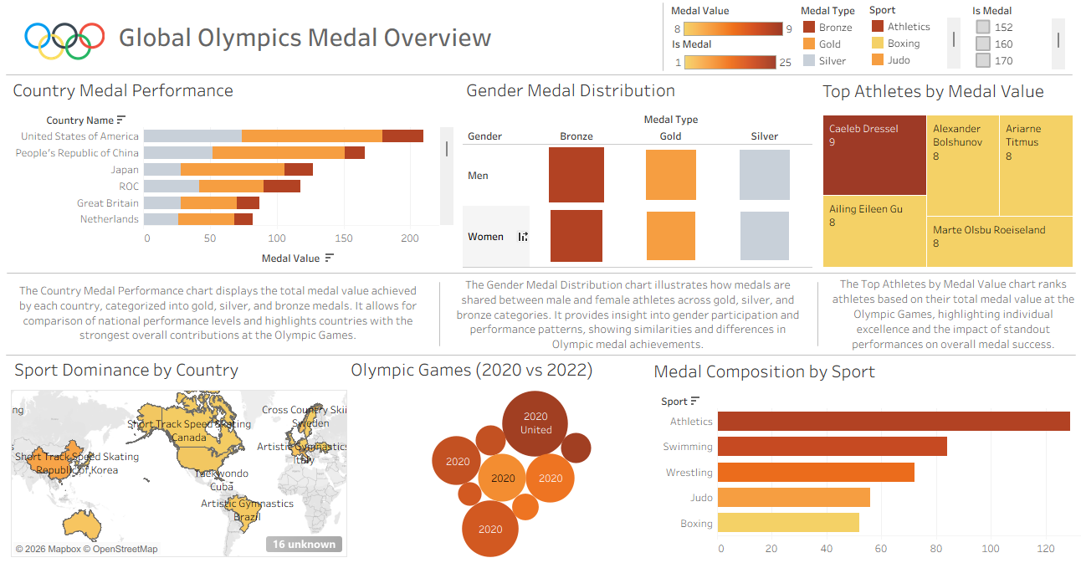
The dashboard consolidates six visualizations, country medal performance, gender medal distribution, top athletes by medal value, sport dominance by country, Olympic Games year comparison, and medal composition by sport, into a single Tableau Story view.
Interactive Version: View the live, interactive dashboard on Tableau Public: https://public.tableau.com/views/GlobalOlympicsMedalOverview/Dashboard?:language=en-US&:sid=&:redirect=auth&:display_count=n&:origin=viz_share_link
Country Medal Performance
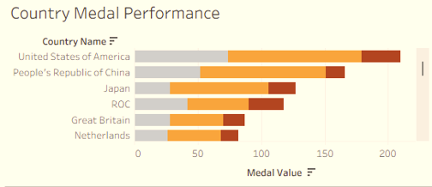
Stacked bar chart ranking the top six countries by total medal value, broken into gold, silver, and bronze. The United States of America leads by a wide margin at over 200, followed by the People's Republic of China at roughly 150, with Japan, ROC, Great Britain, and the Netherlands forming a closer second tier between 70 and 90.
Gender Medal Distribution
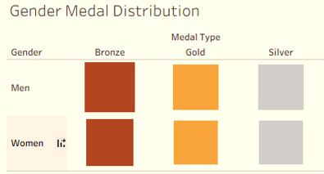
Matrix visualization comparing medal counts between Men and Women across Bronze, Gold, and Silver medal types, showing a broadly balanced distribution by relative size and color intensity across both genders.
Top Athletes by Medal Value
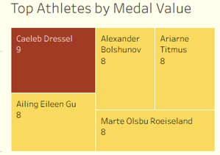
Treemap ranking individual athletes by total medal value. Caeleb Dressel leads at 9, followed by Alexander Bolshunov, Ariane Titmus, Ailing Eileen Gu, and Marte Olsbu Roeiseland, each at 8.
Sport Dominance by Country
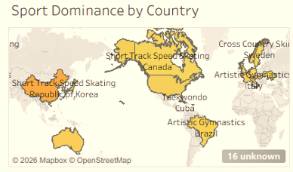
Map highlighting each country's dominant sport. Short Track Speed Skating is linked to the Republic of Korea and Canada, Cross Country Skiing to Sweden, Artistic Gymnastics to Brazil and Italy, and Taekwondo to Cuba, with 16 countries currently marked as unknown.
Olympic Games (2020 vs 2022)
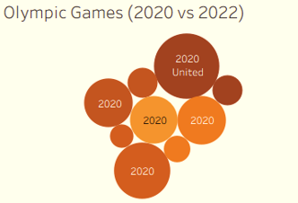
Bubble chart intended to compare performance across the 2020 and 2022 Games. The largest bubble, labeled "2020 United," anchors the chart, though all visible bubbles are currently labeled 2020 rather than showing the intended 2020 versus 2022 split.
Medal Composition by Sport
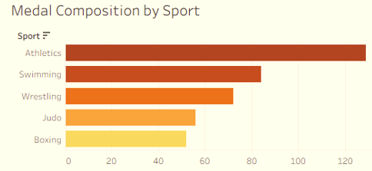
Horizontal bar chart ranking five sports by medal composition. Athletics leads by a wide margin at over 120, followed by Swimming (approximately 85), Wrestling (approximately 70), and Judo and Boxing (both approximately 45 to 50).
Dashboard Summary
Tableau Story representing country medal performance, gender medal distribution, top individual athletes by medal value, sport dominance by country on a world map, an Olympic Games year comparison, and medal composition by sport.
Chapter Five: Observations and Recommendations
Observations
- Medal success is heavily concentrated at the country level, with the United States and China forming a clear top tier well ahead of the rest of the field.
- Elite individual athlete performance is tightly contested at the top, with the five highest-value athletes separated by only a single point.
- Athletics dominates total medal composition by sport, generating substantially more medal volume than any other tracked discipline.
- Sport dominance by country shows clear, specific national specializations, though a meaningful portion of countries (16) remain uncategorized in the current dataset.
- The gender medal distribution chart appears visually balanced between Men and Women, but lacks explicit numeric labels needed to confirm that balance precisely.
- The Olympic Games year comparison chart shows a data or filtering issue, with all bubbles currently labeled 2020 despite the chart's title referencing a 2020 versus 2022 comparison.
Recommendations
- Add explicit data labels to the Gender Medal Distribution chart so gender balance can be confirmed with precise figures rather than relative size and color alone.
- Investigate and correct the labeling issue on the Olympic Games (2020 vs 2022) chart, likely a Year field or filter not populating correctly, since this comparison has real analytical value once fixed.
- Investigate the 16 countries currently marked "unknown" in the Sport Dominance map to determine whether this reflects genuinely mixed sport performance or a data completeness gap.
- Use Japan and ROC's closely matched totals as a natural benchmark pair for deeper competitive analysis between the two nations.
- Treat Athletics' dominant medal composition with appropriate context (its large number of individual events) rather than reading it as disproportionate sport importance on its own.
- Consider adding a filter or breakdown for medal value by sport within each top country, to determine which specific sports are driving the USA and China's leading totals.
Conclusion
This analysis shows that Olympic medal success concentrates sharply at multiple levels, at the country level, where the United States and China form a clear top tier, at the sport level, where Athletics generates far more medal volume than any other discipline, and even at the individual athlete level, where a tightly clustered group of five athletes leads all others.
Country performance confirmed a wide gap between the top two nations and the rest of the field, while sport dominance by country revealed specific, credible national specializations alongside a meaningful data gap in 16 uncategorized countries. Individual athlete performance told a more competitive story, with the top five athletes separated by just a single point of medal value.
Two specific data quality issues surfaced during this analysis, the unlabeled Gender Medal Distribution chart and the mislabeled Olympic Games year comparison, both worth resolving to strengthen the dashboard's overall analytical credibility. Once corrected, the Games-year comparison in particular has strong standalone analytical value that the current version does not yet deliver.
Limitations of the Study
Despite the valuable insights generated, this study has several limitations that should be considered when interpreting the results:
- Missing Data Labels on Key Charts: The Gender Medal Distribution chart does not display exact numeric values, limiting the precision of any conclusions drawn about gender balance to relative visual comparison only.
- Data Labeling Issue on the Games-Year Comparison: The Olympic Games (2020 vs 2022) chart currently shows only 2020-labeled data points, meaning no direct year-over-year comparison could actually be drawn from the current version of the dashboard.
- Incomplete Sport Dominance Mapping: 16 countries are marked as unknown in the Sport Dominance by Country map, limiting how complete the geographic analysis can be considered.
- Approximate Axis Readings: Several observations, particularly for Country Medal Performance and Medal Composition by Sport, are based on visual position along the axis rather than explicit data labels, and should be treated as close approximations rather than exact figures.
Suggestions for Future Work
To build on the findings of this study, future work could explore the following areas:
- Add Data Labels Throughout: Apply explicit numeric labels to the Gender Medal Distribution and other unlabeled charts to allow for precise, rather than approximate, comparisons.
- Resolve the Games-Year Filtering Issue: Correct the Year field or filter behind the Olympic Games (2020 vs 2022) chart so it delivers the year-over-year comparison the title promises.
- Complete the Sport Dominance Mapping: Investigate and resolve the 16 unknown countries in the Sport Dominance map to produce a fully categorized geographic view.
- Sport-Level Breakdown Within Top Countries: Add a drill-down showing which specific sports are driving the United States' and China's leading medal totals.
- Multi-Games Trend Analysis: Once the year comparison chart is corrected, extend the analysis across additional Games years to identify longer-term national and individual performance trends.

